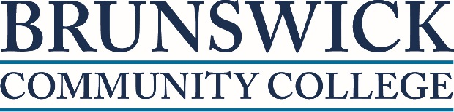
Clinical Medical Assistant (CMA) Student Check Sheet:
This is a 390 Hour Course combining Lecture, Lab & clinical
Course includes Anatomy, Physiology, Pathophysiology, Medical Terminology, Basic Math, legal, fundamental skill sets, Pharmacology, Phlebotomy, EKG, Assisting with Procedures and Clinical rotation at various clinical agencies. Clinical experience: Rotations will take place in variety of Physician/Nurse Practitioner & Physician Assistant offices.
Pre-requisites: All students must be Certified Nurse Aide I on NC state registry and have completed a State Approved Nurse Aide I Course, Completed Career Focus and the Career Readiness Certification Exam, Background check, immunizations and Physical exam prior to registration.
As of August 1, 2016, all students must also complete the 91 hour Anatomy & Physiology course pre-requisite. Scheduled classes for Anatomy & Physiology will begin January 2016

YOU MUST BRING ALL THE ITEMS BELOW TO REGISTER & Make copy for self
___Original Driver’s License, State Issued Identification Card, and Social Security Card or
Passport ( name must match)
___ Career Focus Scores (Must have score for each area - Reading comprehension, math & seeking
information
___ Career readiness Ceritfication with minimum bronze score
___ Background Check & Drug screen receipt from Arc Point Diagnostics in Wilmington
___ Physical Exam & Health History within the past year
___Hepatitis B Vaccine (First Dose & 2nd) Hepatitis Due 6 months from 1st injection
___Tetanus (must be T-DAP) within 10 years
___TB two step Skin Test annually 1st one initial dose, then wait one week and repeat TB test
___MMR (2doses)
___Varicella Titer (if you HAVE HAD the chicken pox)
___Two doses of Varicella Vaccine (if you HAVE NOT had the chicken pox)

Classes will be held:
- Main Campus 8:30am to 3:30pm Mon-Tue-Wed-Thu 8:30am to 3:30pm Fee: $251.00

Topics covered in lecture & laboratory:
- Pharmacology
- EKG Technician
- Phlebotomy
- Assisting with medical office procedures & minor surgery
- Sterile technique & skill sets
- Anatomy, Physiology, Pathophysiology
- Medical Terminology
- HIPPA & legal aspects

Clinical experience: Rotations will take place in variety of Physician offices. Students will have a chance to perform skills and practice the role and responsibilities of the Clinical Medical Assistant under supervision in a clinical setting working alongside Physicians, Nurse Practitioners, Physician Assistants, Medical Assistants and Office Staff.

Students upon Completion of the entire course are eligible for graduation and can take the following National Certifications Examinations:
- Clinical Medical Assistant leading to CCMA certification
- EKG Technician leading to CET certification
- Phlebotomy leading to CPT certification

