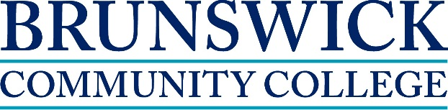

Contemporary Issues in Addictions Treatment
February 9 – April 29, 2015
This is a 96-hour course with classes held on the main campus on Monday and Wednesday from 6pm - 9pm
This course provides a review of the diverse special populations, which are associated with addiction treatment. Emphasis is placed on individuals or groups with specific ethnic, cultural, and gender characteristics as well as persons dealing with HIV, co-occurring disabilities, and persons with criminal justice issues. Upon completion, students should be able to identify the effects, prevention strategies, and treatment methods associated with a kind of special populations.

Course Topics include:
- Effectiveness of current laws in the United States
- Harm reduction strategies within addictions treatment
- Individual and group counseling techniques
- Addiction models and treatment strategies
- Role of heredity
- History and effectiveness of school and community
prevention strategies

Prerequisites for this course: Introduction to Addictions Counseling & Treatment to Addictions

About the instructor:
Jerry Smith has many years’ experience in substance abuse counseling. He has a doctoral degree in Psychology and the following credentials: LPC, LPCS, LCAS, CCS, MAC, NCC, & SAP.

To learn more about the program call 910-755-7408

Students must bring State issued photo identification card and Social Security Card or Passport to register along with High School Diploma or GED. The cost of this program is $180.

Textbook (s) Required: Goldberg, R. (2010). Taking sides: Clashing views on controversial issues in drugs and society (10th Ed.) Dubuque, Iowa: McGraw-Hill.

www.brunswickcc.edu ~ 910-755-7408

