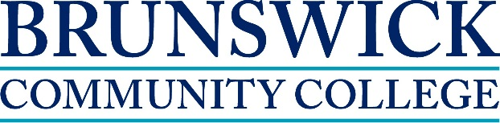

Introduction to Addictions Counseling
January 26 – May 11, 2015
Introduction to Addictions Counseling is the first of three 96-hour courses that will lead to the Substance Abuse Counseling certification. Other courses are Treatment of Addictions and Contemporary Issues in Addition Treatment. This first 96-hour course will be offered online.

Course Topics include:

- Understanding the substance abuse credentialing process
- Core concepts in substance abuse and dependence
- History of drug use & abuse
- The major drugs of abuse/dependence
- Categorization, effects, & abuse potential
- History of substance abuse treatment in the U.S.
- Bio-psycho-social motivations
- Personal values as they relate to drugs
- Basic ethics

About the instructor:
Jerry Smith has many years’ experience in substance abuse counseling. He has a
Doctoral degree in Psychology and the following credentials: LPC, LPCS, LCAS, CCS,
MAC, NCC, & SAP.

To learn more about the program call 910-755-7408

Students must bring State issued photo identification card and Social Security Card or Passport to register along with High School Diploma or GED. The cost of this course is $180.

Textbook: Doweiki, H.E. (2009). Concepts of Chemical Dependency (8th Ed.). Belmont, CA: Brooks/Cole Cengage Learning
www.brunswickcc.edu ~ 910-755-7408

