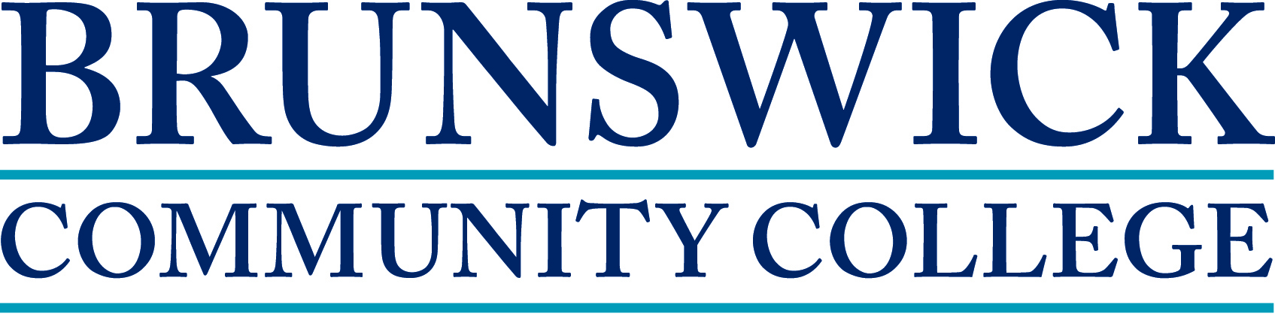

Job Description
Job Title: Learning Resources Specialist FLSA: Non-Exempt
Reports to: Director of Learning Resources Date: May 2014

The incumbent in this position is expected to support the College in achieving its mission and goals. Student focus, college services, and a willingness to assist as needed are expected from all employees.

GENERAL FUNCTION:
The Learning Resources Center of Brunswick Community College supports the mission of the College by providing access to information in a wide variety of formats for students, faculty, staff, and adult residents of Brunswick County, as well as student support for coursework and research. The Learning Resources Specialist provides leadership and accountability through collaborative library planning and assessment, collection management, library instruction, integration of appropriate technology, collaboration with library and ACE staff in providing services and appropriate use of college resources, and consortia collaboration.

ESSENTIAL DUTIES:

- Maintains the physical, electronic, and periodical collection to support all programs offered by the college, seeking faculty input in the acquisition and removal of materials in their program areas;
- Facilitates daily library operations, offering students well-maintained and equipped facilities in a friendly, professional atmosphere, conducive to learning;
- Assists students, faculty, and staff with library resources by providing circulation and reference services;
- Provides instruction in the use of library resources and services to a variety of curriculum and continuing education courses;
- Participates in the development and implementation of library planning, assessment, and reporting;
- Creates and maintains useful resources, tutorials, and guides to help students, faculty, and staff;
- Collaborates with other libraries to provide students and faculty access to materials which are unavailable locally;
- Takes part in the acquisitions process, including selecting, cataloging, and processing materials;
- Ensures that distance learners have access to resources supporting their programs and instruction in the use and evaluation of information;
- Oversees and organizes campus volunteer program.
- Participates in library and ACE cross-training so that both units functions run smoothly and student needs may be addressed at all times;
- Represents Learning Resources on various internal and external committees and makes presentations to various groups concerning the services provided by Learning Resources

MINIMUM REQUIREMENTS:
- Bachelor’s Degree in an academic discipline and one year of library experience, or the equivalent combination of education and experience.
- Employee must be proficient in Microsoft Office, in navigating electronic databases, have experience in providing reference services, and possess a strong understanding of MLA and APA writing styles.

PREFERRED REQUIREMENTS:
- Master’s degree in Library Science from an ALA- accredited university. Community college experience, familiarity with NC LIVE, experience with library instruction, and experience with SIRSI Workflows and Colleague.

PHYSICAL REQUIREMENTS
- Lift, carry, push, pull, or otherwise move objects, exerting up to 10 pounds of force on a frequent basis and up to 20 pounds occasionally;
- Use hands and upper body to operate a variety of machines, tools, and equipment related to office and library processes;
- Walk, stand, reach while handling objects, stoop, and kneel for extended periods of time.
This is a fulltime position. Salary range is determined by the candidate’s education and experience. The position will remain open until filled and subject to budget availability. During the regular class terms, the Learning Resources Center hours are extended until 8 p.m. Monday through Thursday. Evening hours are required. A completed and signed Brunswick Community College application, a letter stating your qualifications related to the position requirements, skills and abilities, transcripts, and resume are required. Applications may be found online at www.brunswickcc.edu. Applicants should send all documents and inquiries to: Human Resources, Brunswick Community College, PO Box 30, Supply, NC, 28462. humanresources@brunswickcc.edu Fax (910) 754-8229 Telephone: (910) 755-7300

BCC is an Equal Opportunity Employer

