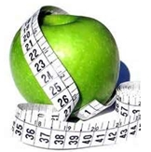
Is a Personal Trainer career for you?
If you like flexible schedules, interaction with the public and motivating people, then you might enjoy a new career as a personal trainer. Becoming a NASM certified personal trainer can give you the best employment advantage due to the organization’s widely respected reputation as a leader in the field of personal training.
NASM Certified Personal Trainer
This course provides students with the necessary skills they will need to become a certified personal trainer. Upon completion of the course, students will be prepared to take the NASM National certification exam. Students will gain knowledge on human anatomy, basic nutrition, kinesiology and exercise physiology and will learn to design their own customized exercise program. Students will be required to have attended a 6-hour American Heart Association CPR and AED certification before completion of this course.
To register, call Continuing Education Department at 910-755-7408
Evening Course ~ January 17 – June 6, 2015
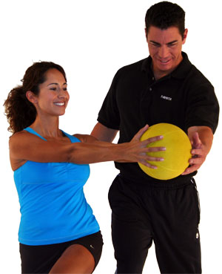
Tues ~ Wed 5:30p.m. – 9:30 p.m. ~ Saturday 8:00am – 4:30 pm
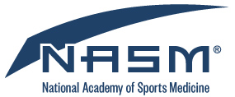
Registration fee $ 180.00
Insurance fee $ 2.50
Textbook $ 100.00 plus tax
Call the BCC bookstore for availability 910-755-7313
NASM certification package fee of $ 450.00 will be due in full to Brunswick Community College approximately 30 days prior to course ending date. This package will include practice tests and the NASM CPT Certification voucher. Once this package is ordered, it is NON-REFUNDABLE

According to the Bureau of Labor Statistics, U.S. Department of Labor, Occupational Outlook Handbook, and (2012-13):
"Employment of fitness trainers and instructors is expected to grow by 24 percent from 2010 to 2020, faster than the average for all occupations. As businesses and insurance organizations continue to recognize the benefits of health and fitness programs for their employees, incentives to join gyms or other fitness facilities will increase the need for workers in these areas."

