To review your financial aid rewards, documents, and academic progress; you must first go to Self-Service. Go and type www.brunswickcc.edu in the URL box, scroll down and click Log on to My BCC.
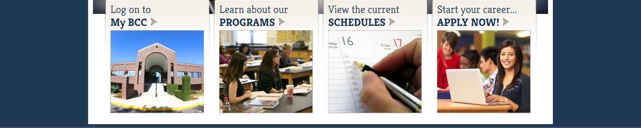

Next, click the icon that says Self-Service
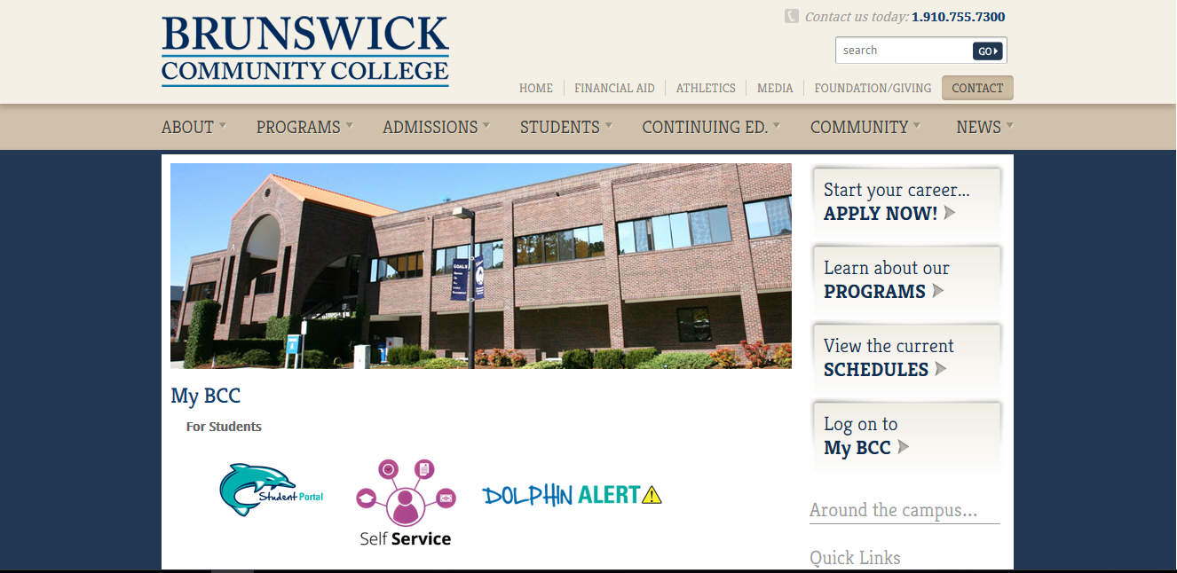

When you login, your username is the first four letters of your name and the last five numbers of your student I.D number. For example, if your name is Johnny it should look like this john56789. Your password is the same password that is used when logging in to Moodle. For example: AppleSeed1234
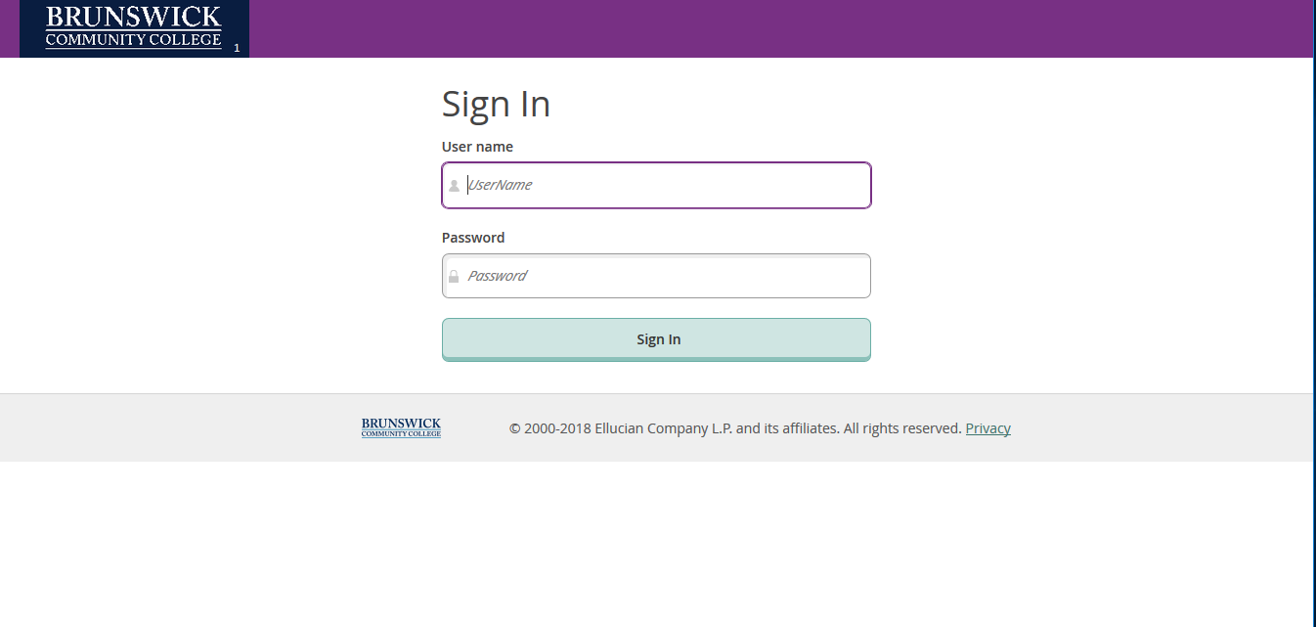

This is what the home page of Self-Service look like. Go and click the Financial Aid tab.
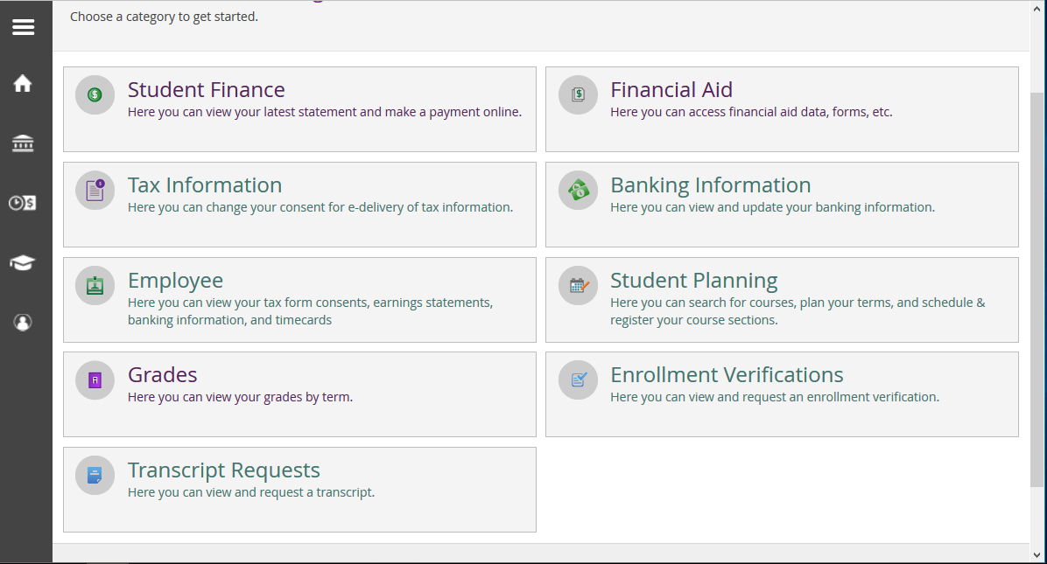

On this page you can review your Financial Aid checklist. This page shows you what documents that you have completed.
If you want to check on other documents from a different year, located at the top left there is a section that says Select an Award Year. Click on the drop down arrow and it will show you other academic years.
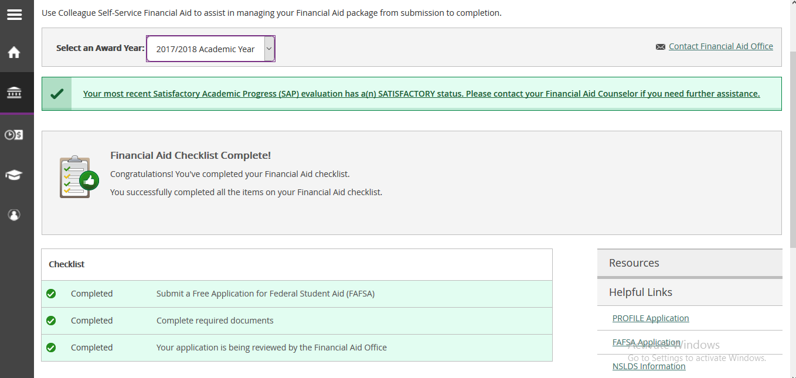
If you want to see what documents that you have not completed, click on the Financial Aid drop down tab and click on required documents. This page will pop up and show you what documents that still need to be completed.
Any documents that are not completed will say Incomplete in yellow.
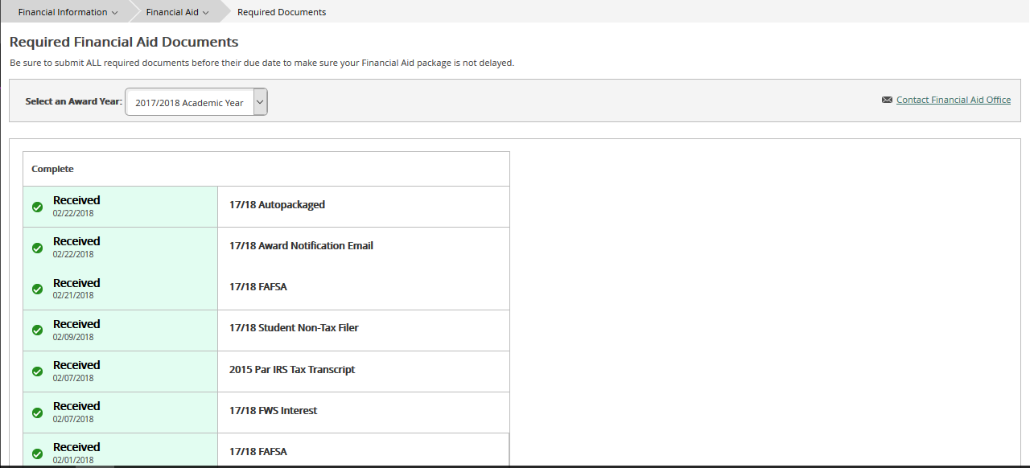

Want to see how you are progressing academically? Go and click the Financial Aid drop down tab at the top and click on Satisfactory Academic Progress.
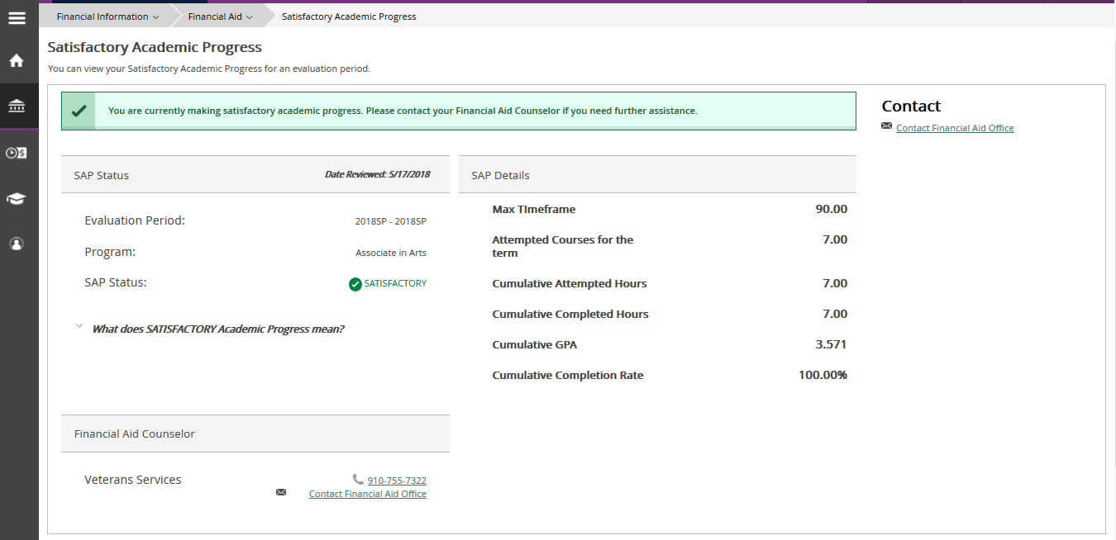

If want to review your reward details, go and click on the Financial Aid drop down tab at the top and click on My Awards. This page will pop up and show you scholarships, grants, and other rewards.

