Brunswick Community College
Application to Evening & Weekend PN Program
Application dates: June 3, 2019 – July 19, 2019
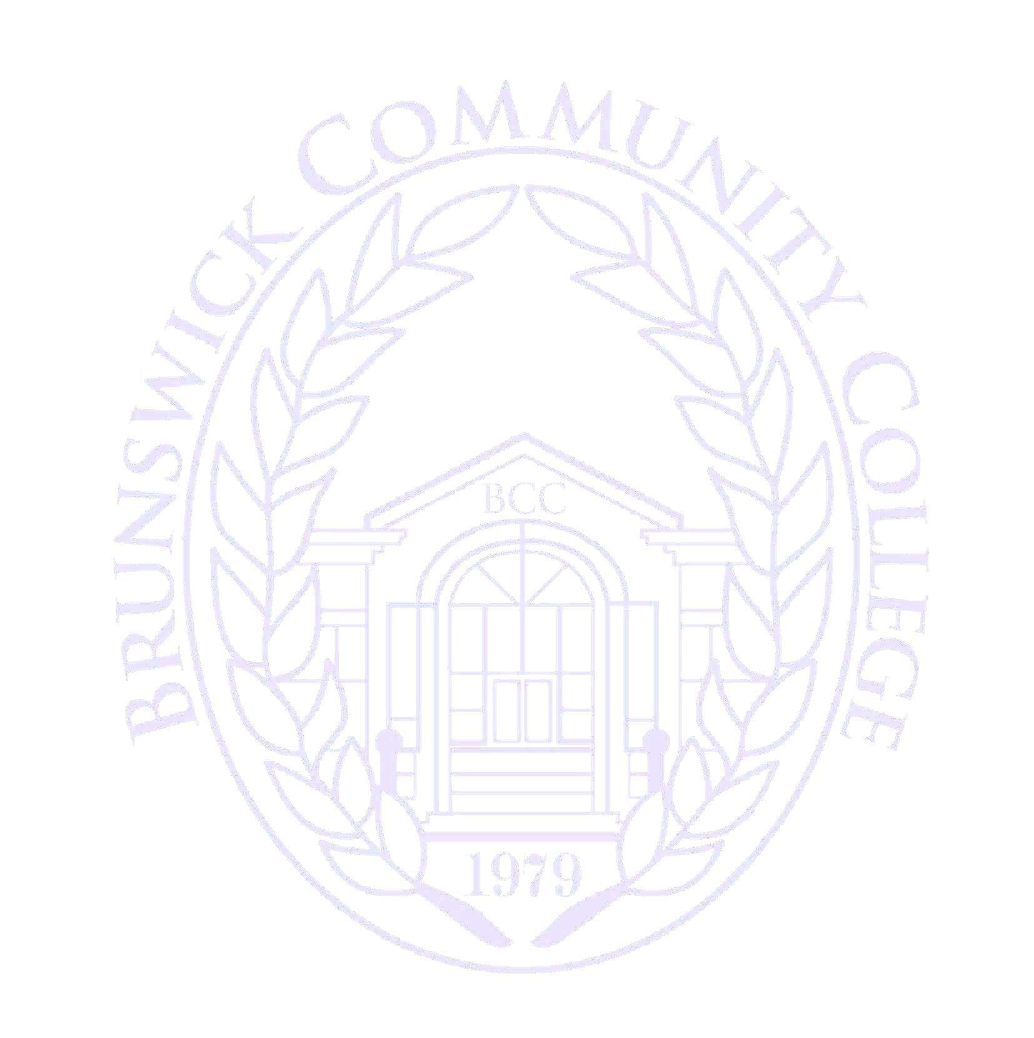
Last Name: First Name: MI:

Mailing Address:

City: State: Zip Code:

Physical Address:

City: State: Zip Code:

Primary Phone: Secondary Phone: Date of Birth:

Campus Email: __Personal Email: _____

Currently Enrolled at BCC: Yes No Last School Attended:

Previous Schools Attended (Please include all schools including high school):

Date of PAX Test Scores to be Used: CNA Expiration Date:

I am applying for admission to the 2019 Evening/Weekend Practical Nursing Program offered at Brunswick Community College. By submitting this application, I agree that I have read the Evening & Weekend Practical Nursing (PN) Admission Brochure and acknowledge that I meet the requirements listed for entry into the program. I further acknowledge that all information provided is true and that misrepresenting the truth can lead to dismissal from the program.

Signature: Date:

- Completed applications must be submitted electronically to Samantha Walker at WalkerS@brunswickcc.edu to be considered for review into the programs. An electronic submission will constitute as your signature.
- Applicants must be admitted to BCC as a general student by 3pm, July 19, 2019.

Students who have taken the NLN PAX examination more than once must state which test score (by date) they wish to use. If the exam was taken at a location other than BCC or prior to 2018, it is the student’s responsibility to ensure that the scores are received by BCC.
Students must submit official transcripts from all institutions attended (including high school) and be accepted to Brunswick Community College as a curriculum student prior to the application deadline to be considered for admission into the nursing programs.

